Working with Dates

Assigning values to a date.
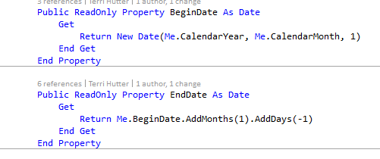

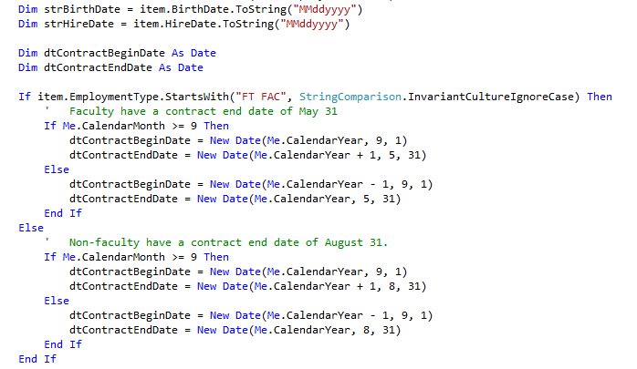
Comparing a date to a fixed value.
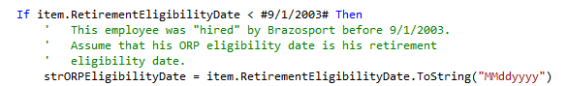

Set a Property to the current date.
Dim dtCreatedDate As New Date(Date.Now.Year, Date.Now.Month, Date.Now.Day)
Dim strCreatedDate As String = dtCreatedDate.ToString("yyyyMMdd")

asset.Header.AssetEventDate = Date.Now.Date

Dim endDate = DateTime.Now.Date

Set a DateTime Property to the current datetime.
Me.VerifiedDate = DateTime.Now

Set a Property to the null date.
Me.VerifiedDate = Nothing

Determine if a string can be converted to a date and convert it if it can.
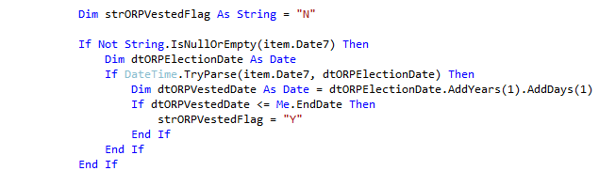
dtDate = DateTime.Parse(strDate).AddDays(-1)

Blog on DateDiff which is not part of the .NET framework but is in the Microsoft.VisualBasic Namespace which is shipped as standard as part of the .NET framework.
https://blogs.msdn.microsoft.com/vbfaq/2004/05/30/how-do-i-determine-the-difference-between-two-dates/
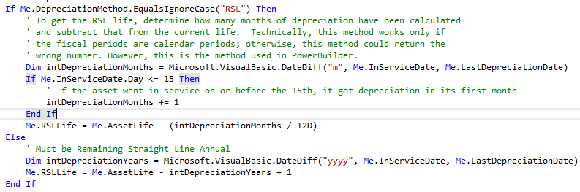
Date Minimum Value
If Me.MinimumGLDate.HasValue AndAlso
Me.MinimumGLDate.Value <> Date.MinValue Then

If CDate(e.Value) < Me.MinimumGLDate.Value Then
e.Cancel = True
e.ErrorMessage = String.Format("GL Date '{0}' must be greater than or equal to the minimum allowed GL Date '{1}'", CDate(e.Value).ToShortDateString, Me.MinimumGLDate.Value.ToShortDateString)
End If

End If

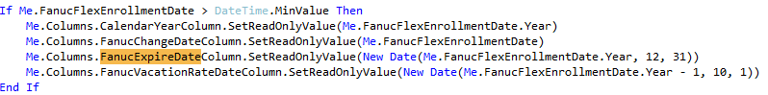
If Me.FanucFlexEnrollmentDate > DateTime.MinValue Then
Me.Columns.CalendarYearColumn.SetReadOnlyValue(Me.FanucFlexEnrollmentDate.Year)
Me.Columns.FanucChangeDateColumn.SetReadOnlyValue(Me.FanucFlexEnrollmentDate)
Me.Columns.FanucExpireDateColumn.SetReadOnlyValue(New Date(Me.FanucFlexEnrollmentDate.Year, 12, 31))
Me.Columns.FanucVacationRateDateColumn.SetReadOnlyValue(New Date(Me.FanucFlexEnrollmentDate.Year - 1, 10, 1))
End If

See if a Date Has a Value
Dim dtTransactionDate As New Date
If item.TransactionDate > Date.MinValue Then
dtTransactionDate = item.TransactionDate
ElseIf item.Date > Date.MinValue Then
dtTransactionDate = item.Date
Else
dtTransactionDate = item.Day
End If

Get the Current DateTime and Compare to a Range of Times on that Day
Protected Overridable ReadOnly Property IsConfiguredForCurrentTime() As Boolean
Get
Dim dtCurrentDateTime = DateTime.Now
Return (
dtCurrentDateTime < New Date(dtCurrentDateTime.Year, dtCurrentDateTime.Month, dtCurrentDateTime.Day, 16, 0, 0) OrElse
dtCurrentDateTime >= New Date(dtCurrentDateTime.Year, dtCurrentDateTime.Month, dtCurrentDateTime.Day, 18, 0, 0)

End Get
End Property

Date Arithmetic
Dim endDate = DateTime.Now.Date
'Begin date is the first of the month, two months prior to the end date
Dim beginDate = endDate.AddMonths(-2)
beginDate = beginDate.AddDays(1 - beginDate.Day)

